**FLOOD MONITORING AND EARLY**

**WARNING**

**ABSTRACT:**

**Flood monitoring and warning system developed by ENVIRA IoT receives accurate and reliable information about real risks, so measures to protect the most vulnerable areas can be established and Public Administrations can collect real data to generate statistics for the design of optimal protection.**

**The IoT based projects that can help collect data from sensors are an added advantage for researchers to explore in providing better services to people. These systems can be integrated with cloud computing and analyzing platforms. Researchers recently have focussed on mathematical modeling based flood prediction schemes rather than physical parametric based flood prediction. The new methodologies explore the algorithmic approaches. There have been many systems proposed based on analog technology to web-based and now using mobile applications.**

**FLOW CHART FOR FLOOD MONITORING AND EARLY WARNING:**

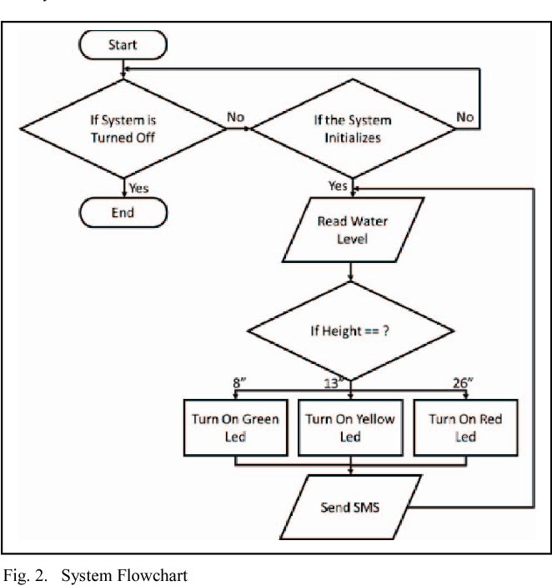

In most countries in the world, flood had caused damages to properties and it involved a large amount of loss to individuals and governments. During flood, it is important to have efficient flood response operation system to manage all activities among different related agencies

The two monitoring devices are composed of Ultrasonic sensor to measure the distance of the water level, Arduino micro-controller that process the signal from the sensor, GSM module to send the data or information from the micro-controller to the computer server and a power source using Solar Panel, Regulator and Batter

The ultimate aim is to build a water level detection using ultrasonic sensor to monitor the rivers in the south-east and south-west portion of the province of Isabela and develop a web and SMS application as an early warning system that provides essential information to the local communities and concern agencies

|  |  |  |  |
| --- | --- | --- | --- |
| **StationID (photo)** | **Station Name (cross section)** | **Dsitrict** | **River Basin (Trend)** |
| 3907403 | Pasang Api | Hilir Perak | Sq.Perak |
| 5108401 | Sq.liok di Bekalan liok | Selama | Sq.Kerian |
| 5206432 | Sq.Krian di selama | Selama | Sq.Kerian |
| 5005405 | samagagah | kerian | Sq.Kurau |
| 4907422 | B14Batukurau | Lrut Matang | Sq.Kurau |
| 5007421 | Sq.kurau di pondok Tanjuna | Selama | Sq.Kurau |
| 5006401 | Kolam Air Bukit Merah | kerian | Sq.Perak |
| 5513401 | Tasik Temengor di Banding | Hulu perak | Sq.Perak |
| 4911445 | Sq.Plus di Kg lintang | kuala Kangsar | Sq.Perak |
| 4809443 | Sq.Perak di Jan Iskandar | kuala Kangsar | Sq.Perak |
| 4409401 | Sq.Perak di Parit | Perak tengah | Sq.Perak |
| 4310401 | Sq.Kinta di Tanjung Tualana | kinta | Sq.Perak |
| 4209493 | Sq.Perak di Teluk sena | Perak Tengah | Sq.Perak |
| 4109401 | Sq.Perak di kampong Gajah | Perak Tengah | Sq.Perak |
| 4611463 | Sq.Kinta di Tanjung Rambutan | kinta | Sq.Kinta/Sq.Perak |
| 5005405 | samagagah | kerian | Sq.Kurau |
| 4907422 | B14Batukurau | Lrut Matang | Sq.Kurau |
| 5007421 | Sq.kurau di pondok Tanjuna | Selama | Sq.Kurau |
| 5006401 | Kolam Air Bukit Merah | kerian | Sq.Perak |
| 5513401 | Tasik Temengor di Banding | Hulu perak | Sq.Perak |
| 4911445 | Sq.Plus di Kg lintang | kuala Kangsar | Sq.Perak |
| 4409401 | Sq.Perak di Parit | Perak tengah | Sq.Perak |
| 4310401 | Sq.Kinta di Tanjung Tualana | kinta | Sq.Perak |
| 4209493 | Sq.Perak di Teluk sena | Perak Tengah | Sq.Perak |
| 4109401 | Sq.Perak di kampong Gajah | Perak Tengah | Sq.Perak |
| 4611463 | Sq.Kinta di Tanjung Rambutan | kinta | Sq.Kinta/Sq.Perak |
| 5005405 | samagagah | kerian | Sq.Kurau |
| 5206432 | Sq.Krian di selama | Selama | Sq.Kerian |
| 5005405 | samagagah | kerian | Sq.Kurau |
| 4907422 | B14Batukurau | Lrut Matang | Sq.Kurau |
| 5007421 | Sq.kurau di pondok Tanjuna | Selama | Sq.Kurau |
| 5006401 | Kolam Air Bukit Merah | kerian | Sq.Perak |
| 4209493 | Sq.Perak di Teluk sena | Perak Tengah | Sq.Perak |
| 4109401 | Sq.Perak di kampong Gajah | Perak Tengah | Sq.Perak |
| 4611463 | Sq.Kinta di Tanjung Rambutan | kinta | Sq.Kinta/Sq.Perak |
| 5005405 | samagagah | kerian | Sq.Kurau |
| 4907422 | B14Batukurau | Lrut Matang | Sq.Kurau |
| 5007421 | Sq.kurau di pondok Tanjuna | Selama | Sq.Kurau |
| 5006401 | Kolam Air Bukit Merah | kerian | Sq.Perak |

|  |  |  |  |
| --- | --- | --- | --- |
| **Last6 Update Time** | **River Level** | **(Graph)** | **Normal Level** |
| 6/8/2015 - 22:00 | 0.58 | 1 | |

|  |  |  |
| --- | --- | --- |
| 6/9/2015 - 23:00 | 33.24 | 29 |
| 6/10/2015 - 22:45 | 7.72 | 10 |
| 0:00 | -99.99 | 0 |
| 06/07/2017 - 23:00 | 23.77 | 23.5 |
| 06/07/2017 - 23:30 | 10.53 | 13 |
| 06/07/2017 - 23:00 | 8.25 | 8.68 |
| 06/07/2017 - 23:00 | 243.87 | 240 |
| 06/07/2017 - 23:00 | 52.54 | 52 |
| 06/07/2017 - 23:00 | 31.85 | 32 |
| 06/07/2017 - 23:00 | 17.68 | 18 |
| 06/07/2017 - 23:00 | 10.71 | 10 |
| 06/07/2017 - 23:30 | 8.93 | 8.5 |
| 06/07/2017 - 23:00 | 5.07 | 5 |
| 06/07/2017 - 23:00 | 64.29 | 65 |

|  |  |  |  |  |  |
| --- | --- | --- | --- | --- | --- |
| 6/9/2015 - 23:00 | | 33.24 | | 29 | |
| 6/10/2015 - 22:45 | | 7.72 | | 10 | |
| 0:00 | | -99.99 | | 0 | |
| 06/07/2017 - 23:00 | | 23.77 | | 23.5 | |
| 06/07/2017 - 23:30 | | 10.53 | | 13 | |
| 06/07/2017 - 23:00 | | 8.25 | | 8.68 | |
| 06/07/2017 - 23:00 | | 243.87 | | 240 | |
| 06/07/2017 - 23:00 | | 31.85 | | 32 | |
| 06/07/2017 - 23:00 | | 17.68 | | 18 | |
| 06/07/2017 - 23:00 | | 10.71 | | 10 | |
| 06/07/2017 - 23:30 | | 8.93 | | 8.5 | |
| 06/07/2017 - 23:00 | | 5.07 | | 5 | |
| 06/07/2017 - 23:00 | | 64.29 | | 65 | |
| 06/07/2017 - 23:00 | | 31.85 | | 32 | |
| 06/07/2017 - 23:00 | | 17.68 | | 18 | |
| 06/07/2017 - 23:00 | | 10.71 | | 10 | |
| 06/07/2017 - 23:30 | | 8.93 | | 8.5 | |
| 06/07/2017 - 23:00 | | 5.07 | | 5 | |
| 06/07/2017 - 23:00 | | 64.29 | | 65 | |

|  |  |  |
| --- | --- | --- |
| **Alert Level** | **Warning Level** | **Danger Level** |
| 3 | 3.3 | 4 |
| 35 | 35.15 | 35.5 |
| 12 | 12.3 | 13 |
| 0 | 0 | 0 |
| 24 | 24.7 | 25.4 |
| 15 | 15.24 | 15.8 |
| 9 | 9.04 | 9.14 |
| 247 | 247.69 | 248.38 |
| 54 | 54.24 | 54.8 |
| 35 | 35.65 | 36.3 |
| 19 | 20.7 | 21.6 |
| 13 | 13.75 | 14.5 |
| 11 | 11.9 | 12.8 |
| 6.5 | 6.65 | 7 |
| 66.5 | 67.15 | 67.8 |
| 24 | 24.7 | 25.4 |
| 15 | 15.24 | 15.8 |
| 9 | 9.04 | 9.14 |
| 247 | 247.69 | 248.38 |
| 54 | 54.24 | 54.8 |
| 35 | 35.65 | 36.3 |
| 0 | 0 | 0 |
| 24 | 24.7 | 25.4 |
| 15 | 15.24 | 15.8 |
| 35 | 35.65 | 36.3 |
| 19 | 20.7 | 21.6 |
| 13 | 13.75 | 14.5 |
| 11 | 11.9 | 12.8 |
| 6.5 | 6.65 | 7 |
| 66.5 | 67.15 | 67.8 |
| 24 | 24.7 | 25.4 |
| 0 | 0 | 0 |
| 24 | 24.7 | 25.4 |
| 15 | 15.24 | 15.8 |
| 35 | 35.65 | 36.3 |
| 19 | 20.7 | 21.6 |
| 247 | 247.69 | 248.38 |
| 54 | 54.24 | 54.8 |
| 35 | 35.65 | 36.3 |
| 19 | 20.7 | 21.6 |

**BLOCK DIAGRAM:**

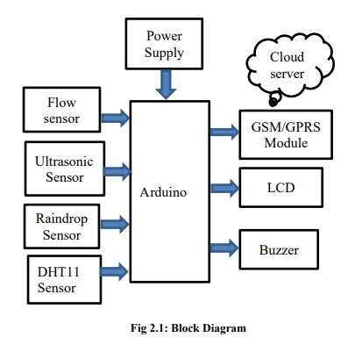

**PROGRAM(python):**

ine BLYNK_TEMPLATE_NAME "IOT FLOOD MONITORING"

#define BLYNK_AUTH_TOKEN "gy2bzR-i-RbPW3oWOpAiDgr6sSVzIHVZ"

#define BLYNK_TEMPLATE_ID "TMPL3tobBFjj-"

#def

char auth[] = BLYNK_AUTH_TOKEN;

char ssid[] = "Wokwi-GUEST";

char pass[] = "";

#define BLYNK_PRINT **Serial**

#include <WiFi.h>

#include <WiFiClient.h>

#include <BlynkSimpleEsp32.h>

#include <ESP32Servo.h>

Servo gate;

const int trigPin=2;//d2

const int echoPin=4;//d4

const int servoPin = 18;//d18

long duration;

int distance;

void setup() {

**Serial**.begin(9600);

  Blynk.begin(auth, ssid, pass);

   pinMode(trigPin, OUTPUT);

   pinMode(echoPin, INPUT);

   gate.attach(servoPin, 500, 2400);

}

**Libraries.txt**

**#Wokwi Library List**

**# See** [**https://docs.wokwi.com/guides/libraries**](https://docs.wokwi.com/guides/libraries)

**Blynk**

**DHT12 sensor library**

**DHT sensor library**

**Serve**

**ESP32Servo**

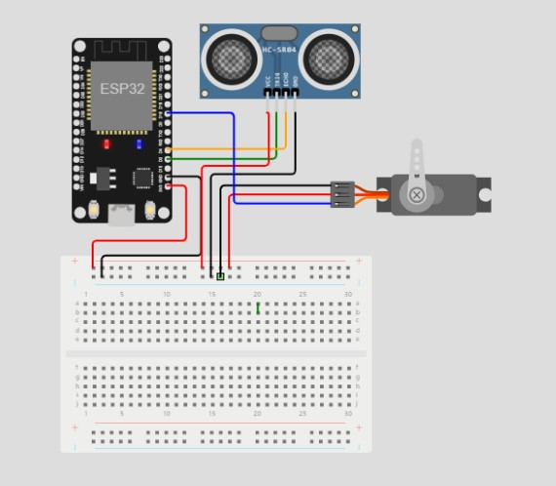

**OUTPUT:**

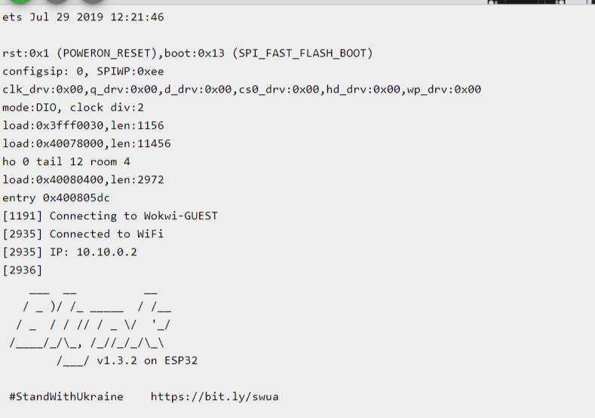

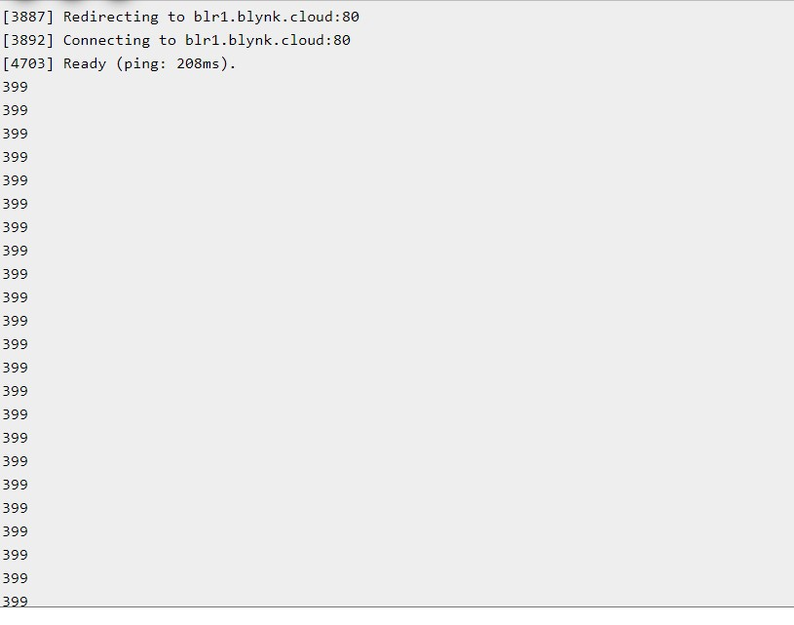

Floods and water resource management are major challenges for human in present and the near future, and snowmelt floods which usually break out in arid or semi-arid regions often cause tremendous social and economic losses, and integrated information system (IIS) is valuable to scientific and public decision-making. This paper presents an integrated approach to snowmelt floods early-warning based on geoinformatics (i.e. remote sensing (RS), geographical information systems (GIS) and global positioning systems (GPS)), Internet of Things (IoT) and cloud services. It consists of main components such as infrastructure and devices in IoT, cloud information warehouse, management tools, applications and services, the results from a case study shows that the effectiveness of flood prediction and decision-making can be improved by using the IIS.

**PROGRAM(python):**

#define BLYNK_TEMPLATE_ID "TMPL3tobBFjj-"

#define BLYNK_TEMPLATE_NAME "IOT FLOOD MONITORING"

#define BLYNK_AUTH_TOKEN "gy2bzR-i-RbPW3oWOpAiDgr6sSVzIHVZ"

char auth[] = BLYNK_AUTH_TOKEN;

char ssid[] = "Wokwi-GUEST";

char pass[] = "";

#define BLYNK_PRINT **Serial**

#include <WiFi.h>

#include <WiFiClient.h>

#include <BlynkSimpleEsp32.h>

#include <ESP32Servo.h>

Servo gate;

const int trigPin=2;//d2

const int echoPin=4;//d4

const int servoPin = 18;//d18

long duration;

int distance;

void setup() {

**Serial**.begin(9600);

  Blynk.begin(auth, ssid, pass);

   pinMode(trigPin, OUTPUT);

   pinMode(echoPin, INPUT);

   gate.attach(servoPin, 500, 2400);

}

void loop()

{

 digitalWrite(trigPin, LOW);

 delay(2);

 digitalWrite(trigPin,HIGH);

 delay(10);

 digitalWrite(trigPin, LOW);

 duration=pulseIn(echoPin,HIGH);

 distance=duration*0.034/2;

**Serial**.println(distance);

 Blynk.virtualWrite(V0,distance);

if(distance<50)

{

  gate.write(90);

 Blynk.virtualWrite(V1,"FLOOD DETECTED GATES OPENED");

}

else

{

  gate.write(0);

Blynk.virtualWrite(V1,"SAFE CONDITIONS GATES CLOSED");

}

}

**Libraries.txt**

**# Wokwi Library List**

**# See https://docs.wokwi.com/guides/libraries**

**Blynk**

**DHT12 sensor library**

**DHT sensor library**

**Servo**

**ESP32Servo**

**OUTPUT:**

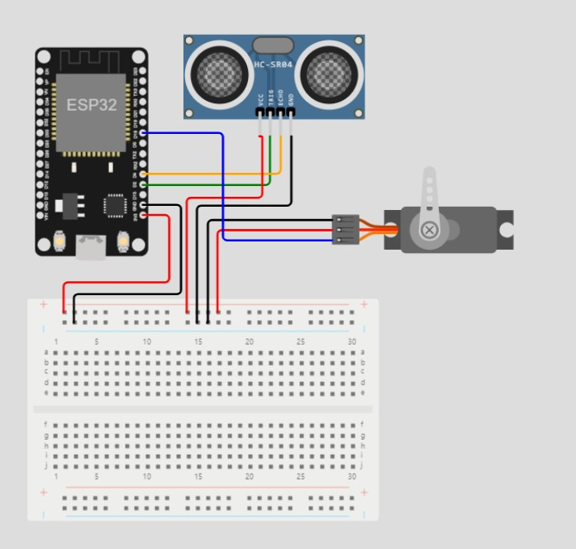

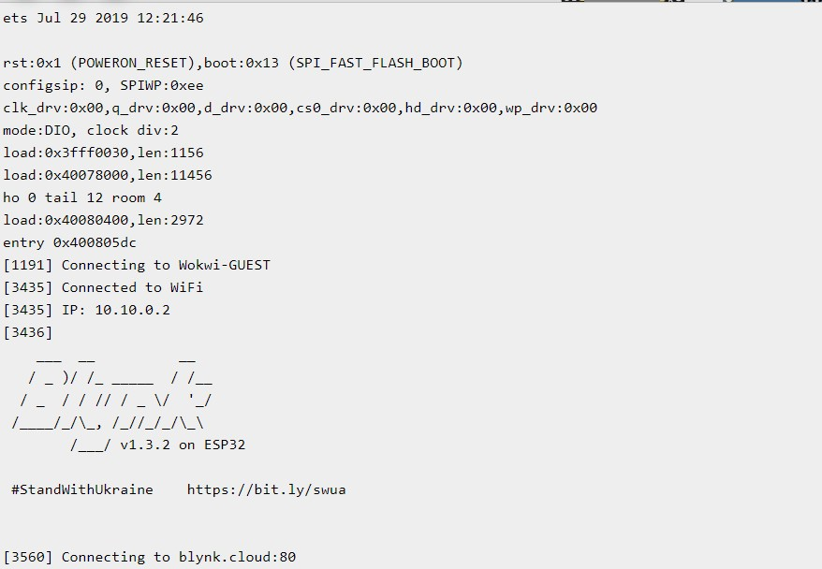

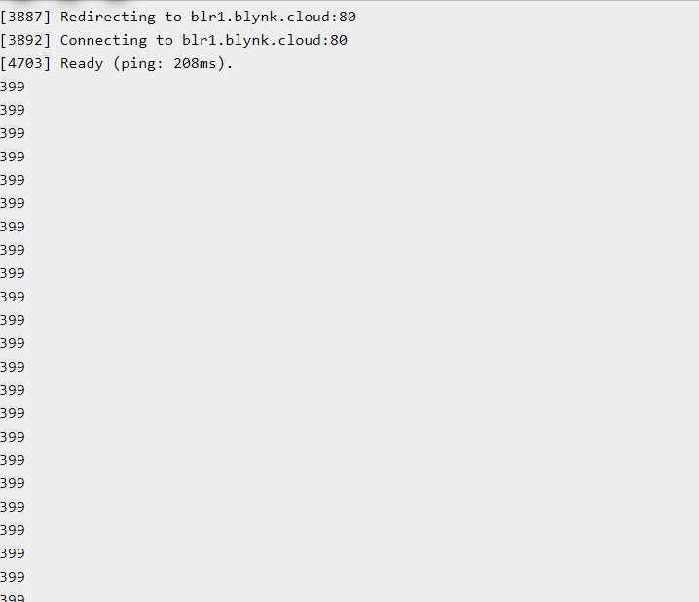

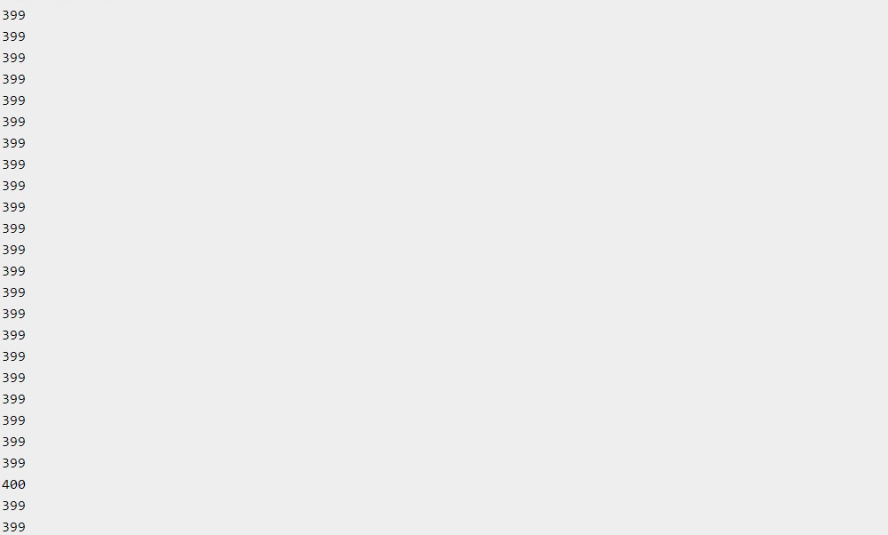



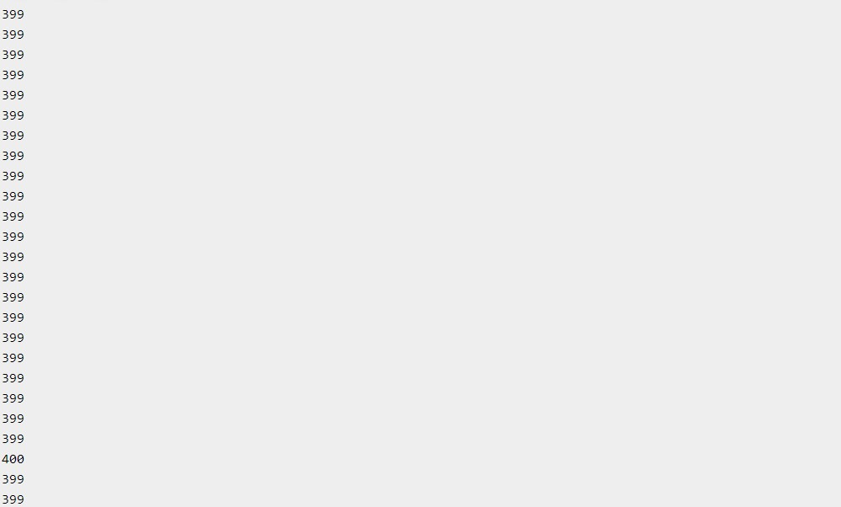



Conclusion:

**The potential to create an alarm system that will mitigate risk of flooding is highlighted by this project. Since the project is equipped with IOT technology, any location in the world can access the sensor data. To produce a more precise and effective flood detection system, more sensors can be added to the system. It may also help a number of government organisations or authorities that ultimately aid society and humanity in dealing with dangerous natural disasters like floods. It will keep an eye on all potential sources of flooding. It will quickly transmit a warning if the water level increases along with the speed. Also, it makes dealing with and recovering from this disastrous situation more accessible. In conclusion, it will assist the community in making timely decisions and developing plans to combat this dangerous natural calamity, such as the flood.**